SUMMER TRAINING/INTERNSHIP REPORT
(Term Aug-Dec 2026)

Submitted by

Yerukola Ashrith Registration Number :12406312

School of Computer Science and Engineering



1

DECLARATION
I hereby declare that this report entitled 'Contact Management System' is an original work carried out during my summer training and has not been submitted elsewhere for any academic award. This section elaborates the concepts, design choices, implementation details and learning outcomes associated with the project. The discussion aligns with the summer training report conventions followed by engineering institutions and provides detailed documentation for academic evaluation.
I hereby declare that this report entitled 'Contact Management System' is an original work carried out during my summer training and has not been submitted elsewhere for any academic award. This section elaborates the concepts, design choices, implementation details and learning outcomes associated with the project. The discussion aligns with the summer training report conventions followed by engineering institutions and provides detailed documentation for academic evaluation.

2
CERTIFICATE

3
ACKNOWLEDGEMENT
I express my sincere gratitude to Lovely Professional University, faculty members and mentors for their guidance and support during the training. This section elaborates the concepts, design choices, implementation details and learning outcomes associated with the project. The discussion aligns with the summer training report conventions followed by engineering institutions and provides detailed documentation for academic evaluation.
I express my sincere gratitude to Lovely Professional University, faculty members and mentors for their guidance and support during the training. This section elaborates the concepts, design choices, implementation details and learning outcomes associated with the project. The discussion aligns with the summer training report conventions followed by engineering institutions and provides detailed documentation for academic evaluation

4

INTRODUCTION OF ORGANIZATION
- Organization Name: Lovely Professional University (LPU)
- Location: Phagwara, Punjab, India
- Type of Organization: Private University
- Established Year: 2005
- Founder/Chancellor: Dr. Ashok Kumar Mittal
- Vision: To become a globally recognized university providing quality education and research opportunities.
- Mission: To prepare students with professional skills, innovation, and entrepreneurship.
- Programs Offered: Engineering, Management, Law, Pharmacy, Agriculture, Design, Arts, and many more.
- Campus Facilities: Smart classrooms, laboratories, hostels, library, sports complex, hospital, shopping mall, and research centers.
- Student Strength: More than 30,000 students from India and many other countries study at LPU.

5
SUMMER TRAINING COURSE/INTERNSHIP CONTENT DETAIL
The summer training mainly focused on Data Structures and Algorithms concepts and their implementation using the C++ programming language. The topics covered included linear data structures such as arrays, linked lists, stacks, and queues, as well as non-linear data structures such as trees and graphs. Various searching techniques including Linear Search and Binary Search and sorting techniques such as Bubble Sort, Selection Sort, Insertion Sort, Merge Sort, and Quick Sort were studied and implemented. The training also covered important algorithmic concepts such as recursion, dynamic programming, greedy algorithms, backtracking, and divide and conquer techniques. These concepts helped in improving problem-solving skills, logical thinking, and the ability to design efficient algorithms for real-world applications. The knowledge gained during the training was applied in the development of the Contact Management System project.

SUMMER TRAINING/ INTERNSHIP PROJECT DETAIL
The Contact Management System is a menu-driven application developed using the C++ programming language to manage contact information efficiently and accurately. The system allows users to perform various operations such as adding new contacts, displaying all contacts, searching for a contact, updating existing contact details, and deleting unwanted contacts. The project uses structures to represent contact information and an array of structures to store multiple records. Various programming concepts such as functions, loops, conditional statements, arrays, and string handling functions have been used in the implementation. The system also includes features such as phone number validation, email validation, and duplicate checking to ensure the accuracy and reliability of stored data. This project provided practical experience in applying Data Structures and Algorithms concepts and improved programming, debugging, and problem-solving skills.
6

PROBLEM STATEMENT
Managing contact information manually is time-consuming and prone to errors such as duplicate entries and incorrect details. The Contact Management System is designed to provide a simple menu-driven solution for efficiently adding, displaying, searching, updating, and deleting contacts. The system also includes phone number validation, email validation, and duplicate checking to ensure accurate and reliable contact management.

PROJECT OBJECTIVES.
- To develop a simple and user-friendly Contact Management System.
- To store and manage contact information efficiently.
- To provide facilities for adding, searching, updating, and deleting contacts.
- To ensure data accuracy through phone number and email validation.
- To prevent duplicate contact entries in the system.
- To apply C++ programming concepts such as structures, arrays, and functions.
- To improve contact organization and management.
- To provide practical experience in developing a menu-driven application.
- To enhance programming and problem-solving skills.
- To create a reliable and efficient contact management solution.

TECHNOLOGIES USED
Language: C++
Compiler: GCC
Editor: Visual Studio Code
Platform: Windows.
7
DATA STRUCTURES USED
The project uses structures and arrays for contact storage and linear search for retrieval.
- Structures (struct Contact) are used to store contact details such as name, phone number, and email address.
- An array of structures is used to store multiple contacts in memory.
- The project can store a maximum of 100 contacts using the array.
- Arrays provide fast and direct access to contact records using indices.
- Linear Search is used to find a contact by its name.
- The search operation checks each contact one by one until the required contact is found.
- Arrays simplify the implementation of display, update, and delete operations.
- String data structures (character arrays) are used to store names, phone numbers, and email addresses.
- The current implementation uses static memory allocation for contact storage.
- Future versions of the project can use Linked Lists or Binary Search Trees (BSTs) to support dynamic and efficient storage.

8
PROJECT MODULES
Modules include Add Contact, Display Contacts, Search Contact, Update Contact and Delete Contact.
Module 1: Structure Definition Module
This module defines the structure used to store contact details.
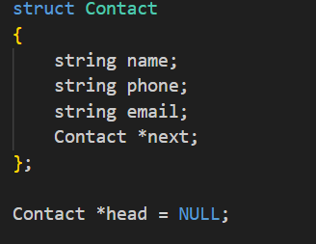
Fig-1
Purpose:
- Stores contact information.
- Creates an array to store up to 100 contacts.
- Maintains the total number of contacts.

Module 2: Phone Validation Module
This module validates whether the entered phone number contains exactly 10 digits.
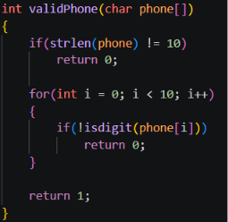
Fig-2
Purpose:
- Ensures the phone number contains only digits.
- Prevents invalid phone numbers from being stored.

Module 3: Email Validation Module
This module checks whether the email ends with @gmail.com.
9
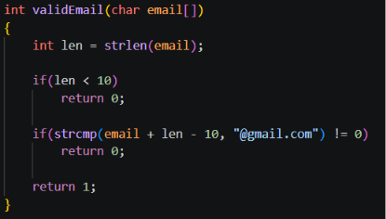
Fig-3
Purpose:
- Validates email format.
- Ensures only Gmail addresses are accepted.

Module 4: Add Contact Module
This module adds a new contact to the system.

10
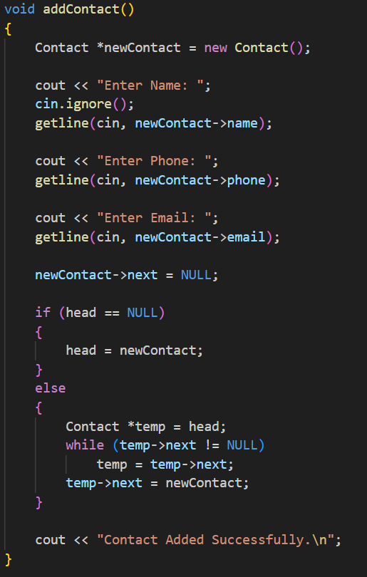
Fig-4

11

Functions Performed:
- Accepts contact details.
- Validates phone number.
- Validates email address.
- Checks for duplicate phone numbers.
- Checks for duplicate email addresses.
- Stores the new contact.

Module 5: Display Contact Module
This module displays all stored contacts.
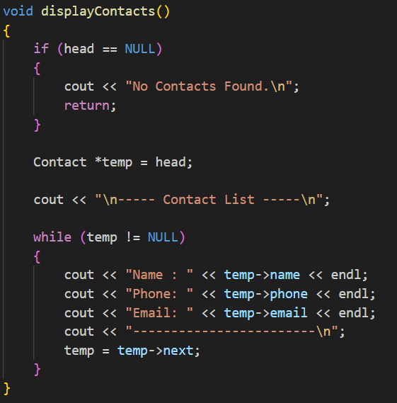
Fig-5
Functions Performed:
- Displays contact name.
- Displays phone number.
- Displays email address.
- Shows total number of contacts.

Module 6: Search Contact Module
This module searches for a contact using the contact name.

12
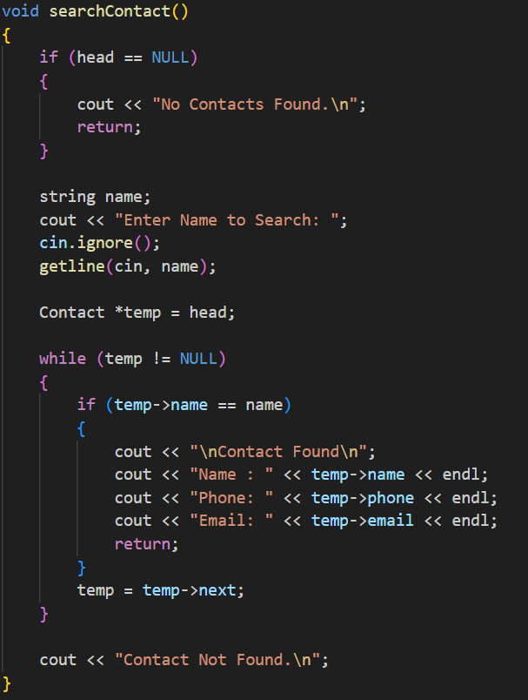
Fig-6
Functions Performed:
- Accepts contact name as input.
- Uses linear search to find the contact.
- Displays contact details if found.

Module 7: Update Contact Module
This module updates existing contact information.

13
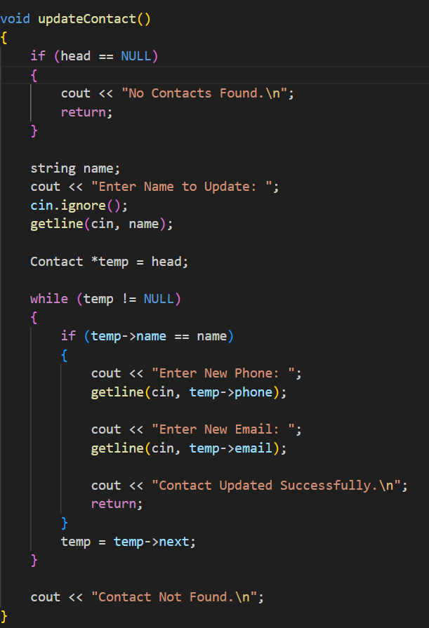
Fig-7

14
Functions Performed:
- Searches for the contact.
- Updates phone number.
- Updates email address.
- Performs validation checks.
- Prevents duplicate records.

Module 8: Delete Contact Module
This module deletes a contact from the system.
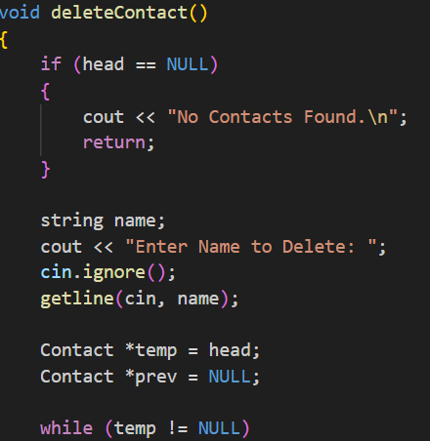
Fig-8
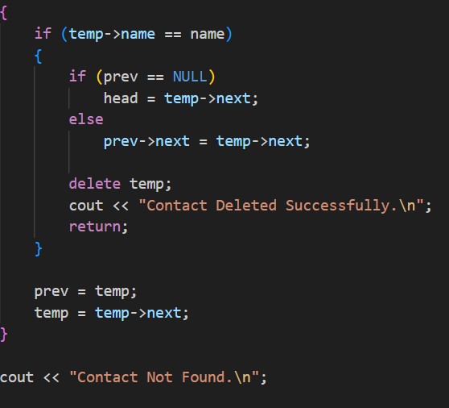
Fig-9
15

Functions Performed:
- Searches for the contact.
- Displays contact details.
- Takes confirmation from the user.
- Deletes the contact record.
- Shifts remaining records to maintain continuity.

Module 9: Main Menu Module
This module controls the entire application.

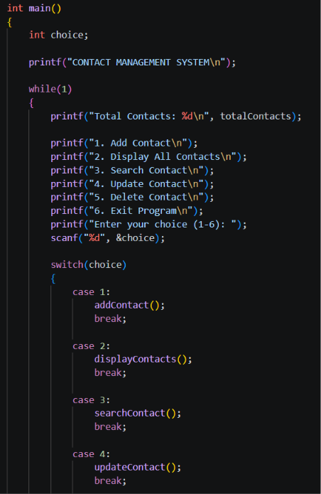
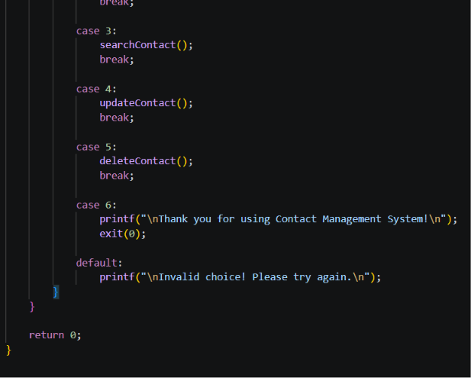

Fig-13

16
Functions Performed:
- Displays the main menu.
- Accepts user choice.
- Calls the corresponding function.
- Continues execution until the user exits.
Module 10: Exit Module
This module terminates the application safely.

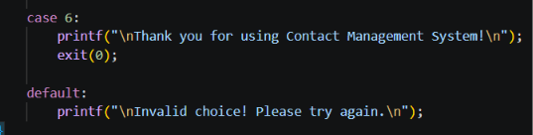
Purpose:
- Displays exit message.
- Terminates the program gracefully.

17

ADVANTAGES
Simple design, easy operation, low memory usage and improved organization of contacts.
- Provides a simple and user-friendly interface.
- Allows quick and easy addition of contacts.
- Supports searching contacts by name.
- Enables updating of existing contact information.
- Allows deletion of unnecessary contacts.
- Prevents duplicate phone numbers from being stored.
- Prevents duplicate email addresses from being stored.
- Validates phone numbers to ensure correct input.
- Validates email addresses to improve data accuracy.
- Uses low memory and system resources, making it efficient and lightweight.

18

LIMITATIONS
Data is stored temporarily and is lost when the program closes.
- The current system uses volatile memory for storing contacts.
- Contact information is stored only during program execution.
- All data is lost when the program is closed.
- The project does not use file handling for permanent storage.
- Contacts cannot be recovered after restarting the application.
- The storage capacity is limited to 100 contacts.
- The system does not support database integration.
- Contacts cannot be sorted automatically.
- Searching is performed using linear search, which becomes slower for larger datasets.
- The application provides a command-line interface only and does not include a graphical user interface (GUI).

19
IMPLEMENTATION DETAILS
- The project is implemented using the C++ programming language.
- A menu-driven approach is used to allow users to select different operations.
- The Add Contact module is used to insert new contact records.
- The Display Contact module shows all stored contacts.
- The Search Contact module finds contacts using the contact name.
- The Update Contact module allows modification of existing contact details.
- The Delete Contact module removes unwanted contacts from the list.
- The system performs phone number validation to ensure exactly 10 digits are entered.
- The system performs email validation to ensure the email ends with @gmail.com.
- Duplicate phone numbers are not allowed in the system.
- Duplicate email addresses are not allowed in the system.
- The project uses arrays of structures to store contact information.
- String handling functions such as strcmp(), strcpy(), and strlen() are used for processing data.
- Loops are used to traverse the contact list and perform operations.
- Conditional statements are used to control program flow and validate inputs.
- The project follows a modular programming approach using separate functions for each operation.
- The program continuously runs until the user selects the Exit option.
- The application displays appropriate success and error messages for better user interaction.
- Input validation improves the accuracy and reliability of stored information.
- The implementation ensures efficient management of contact records within the specified limit of 100 contacts.

20
FUTURE SCOPE
- The project can be improved by adding:
- File handling for permanent contact storage
- Database integration
- Graphical User Interface
- Contact sorting
- Case-insensitive searching
- Search using phone numbers
- Search using email addresses
- Contact categories
- User login and authentication
- Cloud backup
- Contact import and export options

21
PROJECT OUTCOMES
After completing the Contact Management System project:
- Improved understanding of C++ programming
- Learned the practical use of structures
- Learned to use arrays of structures
- Improved knowledge of functions
- Implemented input validation
- Implemented duplicate checking
- Improved logical thinking
- Improved debugging skills
- Gained experience in developing a menu-driven application

22
CONCLUSION
The Contact Management System was successfully developed using the C++ programming language.
- The system provides important contact management operations such as:
- Adding contacts
- Displaying contacts
- Searching contacts
- Updating contacts
- Deleting contacts
- Phone number validation, Gmail validation, and duplicate checking improve the accuracy of the stored information.
- This project helped in improving programming knowledge, logical thinking, problem-solving abilities, and practical software development skills.

23
BIBLIOGRAPHY
The C++ Programming Language by Kernighan and Ritchie.
Data Structures Using C by Reema Thareja.
GCC Compiler Documentation.
Visual Studio Code Documentation.

24

